Joshua Zubrzycki
Macroderma gigas

Cool, dark and quiet; I was home surrounded by my family, and I was happy. My family has survived in these limestone caves since their creation. The cave ceiling has been rarely disturbed since we have chosen to live there. Or perhaps we chose to live there because it is not often disturbed. Regardless the reason, we have grown on these caves and much as they have grown on us. We adore the constant cool air, the relentless dark and the comforting silence the cave offers us.
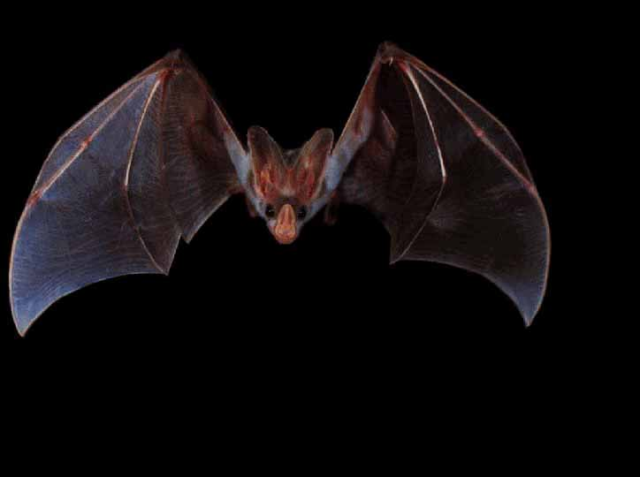
I am Gigas and my father is Macroderma, and his father is Megadrematidae, and on it goes; Chiroptera, Mammalia, Chordatam, to my great ancestor Animalia. Our family stretches back very far, but how far we cannot know. And I should soon find a mate; or else disappoint my heritage, my ancestors.
There are times that we sleep that become difficult to remain comfortable. Creatures in the ground intrude upon our cave, banging, clashing and booming. They emit so much noise, and so much discomfort that may consider moving away from the cave, our cave. But what are we to do? The cave is out home, the intruders make noise and they may follow to where ever we go.
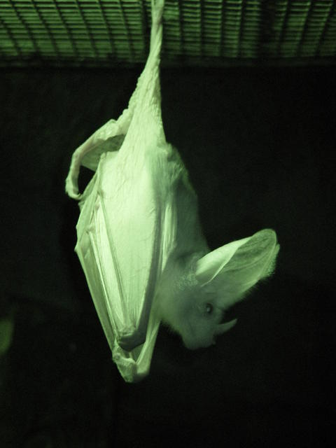
Strange things have been occurring lately. With the onset of the invaders intrusion there is a strange and bizarre mist at the mouth of our cave. We cannot fly through this mist; we get caught in it as though it were some annoyingly strong spider’s web. The web belongs to the invaders; they capture us, and injure our ears and stick a funny leaf there. These creatures fail at killing us, because we escape from their capture every time. But these foolish creatures keep the mist up, when all we need to do is avoid it entirely. On the occasions that we are caught they attach a heavy leaf to out ear, which proves to be nothing but an annoyance. I have realized that toughs that have the leaf are more likely to see the strange creature, yet I do not know why.
I live my life in hope for peace and quiet, I wish for a stop to the noise and the vibrations in my home. I can’t be expected to raise a family with such a disaster happening to my family house, my place of heritage. I have yet to find a spouse, but I do not fret over such things, for I am still a young bat of the age one and a half years.

Works cited

Hoyle, S. D., A. R. Pople, and G. J. Toop. "Mark–recapture may reveal more about ecology than about population trends: Demography of a threatened ghost bat (Macroderma gigas) population." Austral Ecology 26.1 (Feb. 2001): 80-92. Academic Search Premier. EBSCO. [Library name], [City], [State abbreviation]. 22 Mar. 2009 <http://search.ebscohost.com.ezproxy.flcc.edu/login.aspx?direct=true&db=aph&AN=5472160&site=ehost-live>.

"Ghost Bat ." Perth Zoo. 22 Mar 2009 <http://dic.academic.ru/pictures/enwiki/71/Ghost_bat_infrared_Perth_zoo.jpg>.

Creighton , Terry . " Australian False Vampire Bat ." Animal Picture Archieve. 03 Jun 1999 . 22 Mar 2009 <http://www.animalpicturesarchive.com/ArchOLD-4/1128063062.jpg>.

