Pollen grains Images of Ipomoea carnea Plant

Contributer name -Gaikwad N.G
Field-Palynology
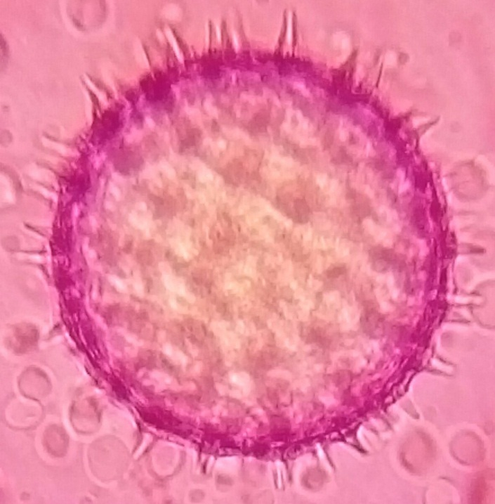
Kingdom: | Plantae
(unranked): | Angiosperms
(unranked): | Eudicots
(unranked): | Asterids
Order: | Solanales
Family: | Convolvulaceae
Genus: | Ipomoea
Species: | I. carnea

